Samuel Kunkel
December 27, 1843 – August 30, 1935

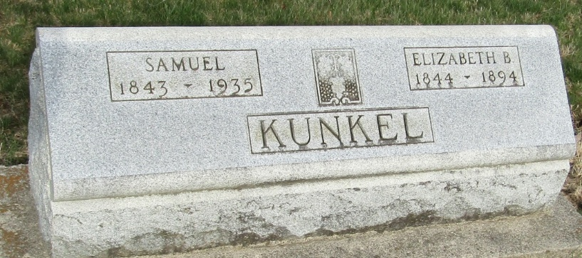

SAMUEL KUNKEL, 92, ANSWERS SUMMONS
DEATH OCCURS TODAY AT HOME NEAR TOCSIN AND FUNERAL SUNDAY

Samuel Kunkel, 92, died at 11:40 today at the home of his daughter, Mrs. William Johns, 1 1/2 miles southwest of Tocsin, of complications following a long illness.
He was born December 27, 1843 to Michael and Margaret Mason Kunkel. His marriage to Elizabeth Blue took place October 8, 1868. She died December 21, 1894.
Surviving are one daughter, Mrs. Izah Jones, near Tocsin, and one brother, John Kunkel, Bluffton.
He was a member of the U.B. Church.
Funeral services will be held at 2 o'clock Sunday at the Jones home. Burial will be in the Murray cemetery.

Evening News-Banner, Wells County, Indiana
Friday, August 30, 1935

**
Indiana, U.S., Death Certificates, 1899-2017

Name Samuel Kunkel
Gender Male
Race White
Marital Status Widowed
Age 91
Birth Date 27 Dec 1843
Birth Place Ohio
Death Date 30 Aug 1935
Death Place Lancaster, Wells, Indiana, USA
Death Registration Date 1935
Father Michael Kunkel
Mother Margaret Mason
Spouse Elizabeth Blue
Informant Mrs. William Jones; Ossian, Indiana
Burial September 1, 1935; Murray Cemetery

