Elizabeth (Blue) Kunkel
August 10, 1844 – December 21, 1894

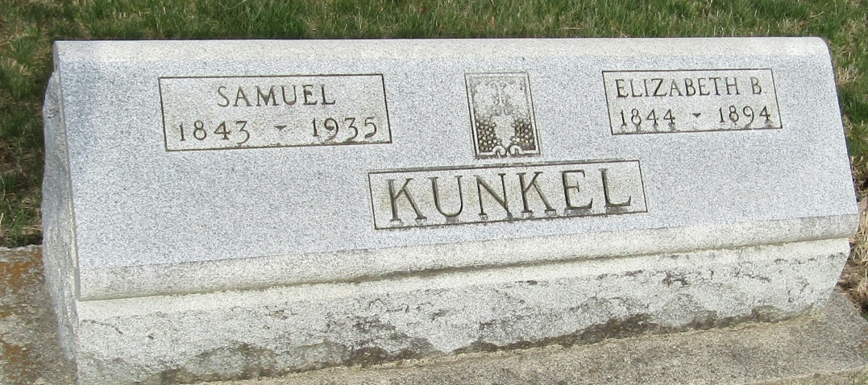

MRS. SAMUEL KUNKEL

Last Friday occurred the death of Elizabeth, wife of Samuel Kunkel, at her home in Tocsin. She had been a sufferer for the past ten years with consumption, and for the past ten months she had been contained to her room. Although suffering thus severely she was at all time patient and resigned.
Mrs. Kunkel was born August 10, 1844, making her age at time of death 50 years, 4 months and 11 days. She was a sister of Representative M. C. Blue. For twenty years previous of her marriage she was engaged in teaching, and was very efficient in the work, ranking at the head of the profession in the county.
She was an excellent woman, much loved by all who were acquainted with her. She was a consistent and devoted member of the Tocsin U. B. Church. Her funeral occurred Saturday at that church, conducted by her pastor Rev. Smith. A large concourse of people by their presence and sympathy attested their high regard for the deceased.
Besides her husband she leaves a daughter, Ivy, who is about twelve years of age, and who feels most keenly the great loss she has sustained in the death of her mother.

Bluffton Banner, Wells County, Indiana
Wednesday, December 26, 1894

**
Elizabeth "Lizzie" Blue Kunkle from tree House Family Tree

Birth 10 Aug 1844 Wells, Indiana, USA
Marriage 8 Oct 1868 Wells, Indiana, USA
Residence 1880 Wells, Indiana, USA
Death 20 Dec 1894 Wells, Indiana, USA
Father Uriah Clement Blue (1807-1867)
Mother Rachel Moore (1807-1877)
Spouse Samuel Kunkle (1843-1935)

