Catherine (Sentz) Kunkel
April 1, 1797 – June 13, 1869

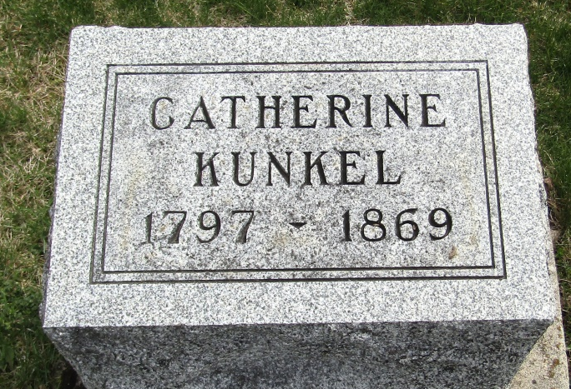

No further information found at this time

