Robert Edwin Kreigh
April 28, 1910 – June 9, 1919

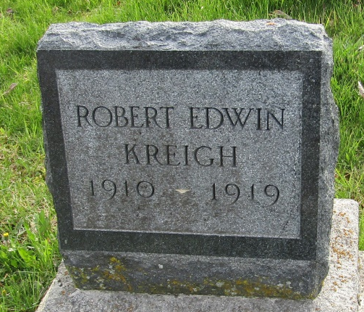

Brave Boy Tried to Save His Companion And Both Meet Death

Bluffton, Indiana, June 10 – The heroic attempt of one boy to save his companion resulted in the death of both when Max Gardiner, aged 7 and Robert Kreigh, aged 9, were drowned in Studebaker quarry, one-half mile east of the city.
Max is the son of Mr. and Mrs. John Gardiner, 425 East Wiley Avenue. Robert is the son of Mr. and Mrs. Glen G. Kreigh, of East Ohio Street.
Witnesses to the accident say that young Gardener was the first to enter the water. After stepping into a deep hole and starting to the bottom, Kreigh tried to rescue him but was himself drowned.

Muncie Evening News, Muncie, Indiana
June 10, 1919

**
Indiana, U.S., Death Certificates, 1899-2017

Name Robert Edwin Kreigh
Gender Male
Race White
Age 9
Birth Date 28 Apr 1910
Birth Place Jefferson Twp. Indiana
Death Date 9 Jun 1919; accidental drowning
Death Place Bluffton, Wells, Indiana, USA
Death Registration Date 1919
Father Glendon Gearald Kreigh
Mother Viola Desie Smith
Informant Glendon Kreigh; father; Bluffton, Indiana
Burial June 11, 1919; Murray Cemetery

