William Fredrick Kleinknight
February 28, 1830 – September 22, 1903

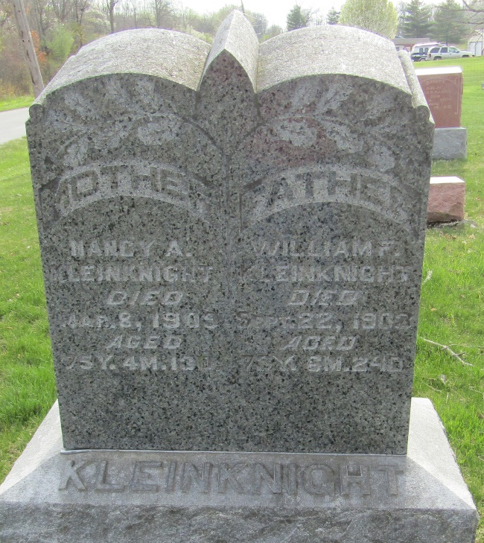

William Fredrick Kleinknight
in the Indiana, U.S., Death Certificates, 1899-2017

Name William Fredrick Kleinknight
Gender Male
Race White
Marital Status Married
Age 73
Birth Date 28 Feb 1830
Birth Place Pennsylvania
Death Date 22 Sep 1903
Death Place Tocsin, Wells, Indiana, USA
Death Registration Date 1903
Father John M Kleinknight
Mother Anna Isenhart
Spouse Amrette
Informant Wm. Kleinknight; Tocsin, Indiana
Burial September 24, 1903; Murray Cemetery

