Peter Kleinknight
January 20, 1822 – September 13, 1855

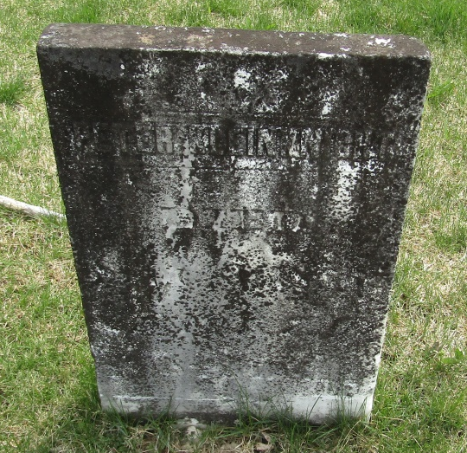

Peter * Kleinknecht Kleinknight from tree Patterson Family Tree

Birth 20 Jan 1822 Berks, Pennsylvania, USA
Marriage 27 Apr 1843 Crawford, Ohio, USA
Residence Jul 1855 Wells, Indiana, USA
Death 13 Sep 1855 Wells, Indiana, USA
Father John* Michael Kleinknecht Kleinknight (1794-1867)
Mother Anna* Isenhardt (1787-1859)
Spouse Elizabeth* Kitch (1814-1873)

