Nancy Amrette (Richey) Kleinknight
October 25, 1833 – March 8, 1909

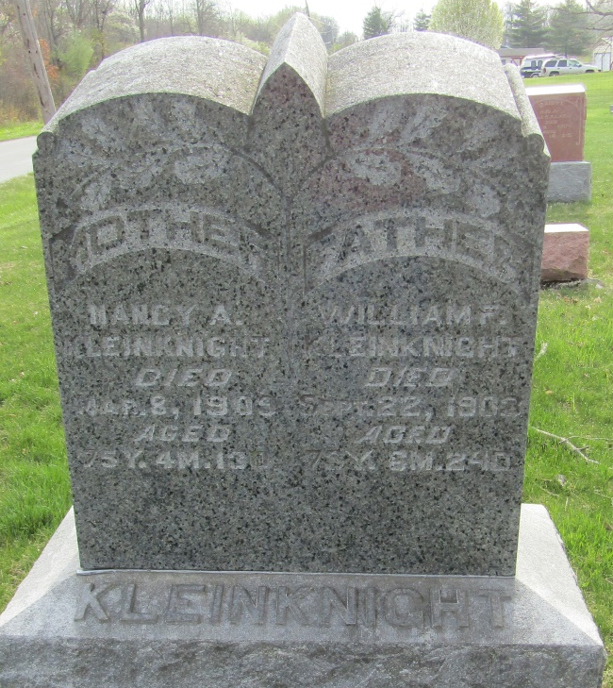

BLUFFTON – Mrs. William Kleiknight died Tuesday morning at her home near Tocsin. She suffered from a stroke of paralysis a few days ago and never fully recovered.

Journal Gazette, Allen County, Indiana
March 11, 1909

**
Nancy Amrette Richey from tree Stoner/Risser/Clark/Jackson

Birth 25 Oct 1833 Licking, Ohio, USA
Marriage 11 Jun 1853 Wells, Indiana, USA
Residence 1900 Wells, Indiana, USA
Death 8 Mar 1909 Bluffton, Wells, Indiana, USA
Spouse William Frederick Kleinknight (1830-1903)

