Mary Ann (Wilkin) Kleinknight
June 17, 1834 – February 15, 1922

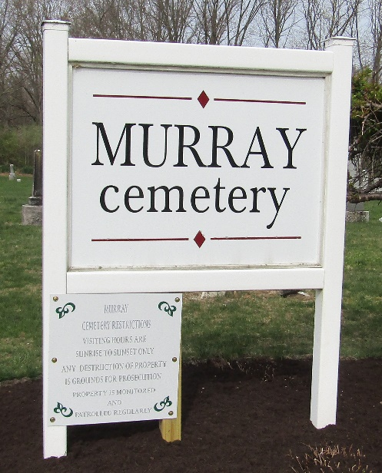

Mary Ann Kleinknight
in the Indiana, U.S., Death Certificates, 1899-2017

Name Mary Ann Kleinknight
[Mary Ann Wilkin]
Gender Female
Race White
Marital Status Widow
Age 87
Birth Date 17 Jun 1834
Birth Place Harrison County, Ohio
Death Date 15 Feb 1922
Death Place Lancaster, Wells, Indiana, USA
Death Registration Date 1922
Father Thos. P Wilkin
Mother Mary Ann Polen
Spouse John Kleinknight
Informant Frank Kleinknight; Bluffton, Indiana
Burial February 17, 1922; Murray Cemetery

