John M. Kleinknight
December 20, 1854 – January 1, 1875

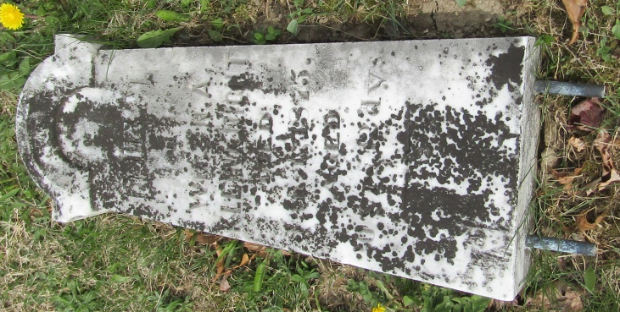

John M Kleinknight from tree Stoner/Risser/Clark/Jackson

Birth 20 Dec 1854 Wells Co IN
Residence 1870 Wells, Indiana, USA
Death 1 Jan 1875 Wells, Indiana, USA
Father William Frederick Kleinknight (1830-1903)
Mother Nancy Amrette Richey (1833-1909)
7196 People 2 Records 4 Sources

