Johann Michael Kleinknight
October 24, 1794 – February 23, 1867

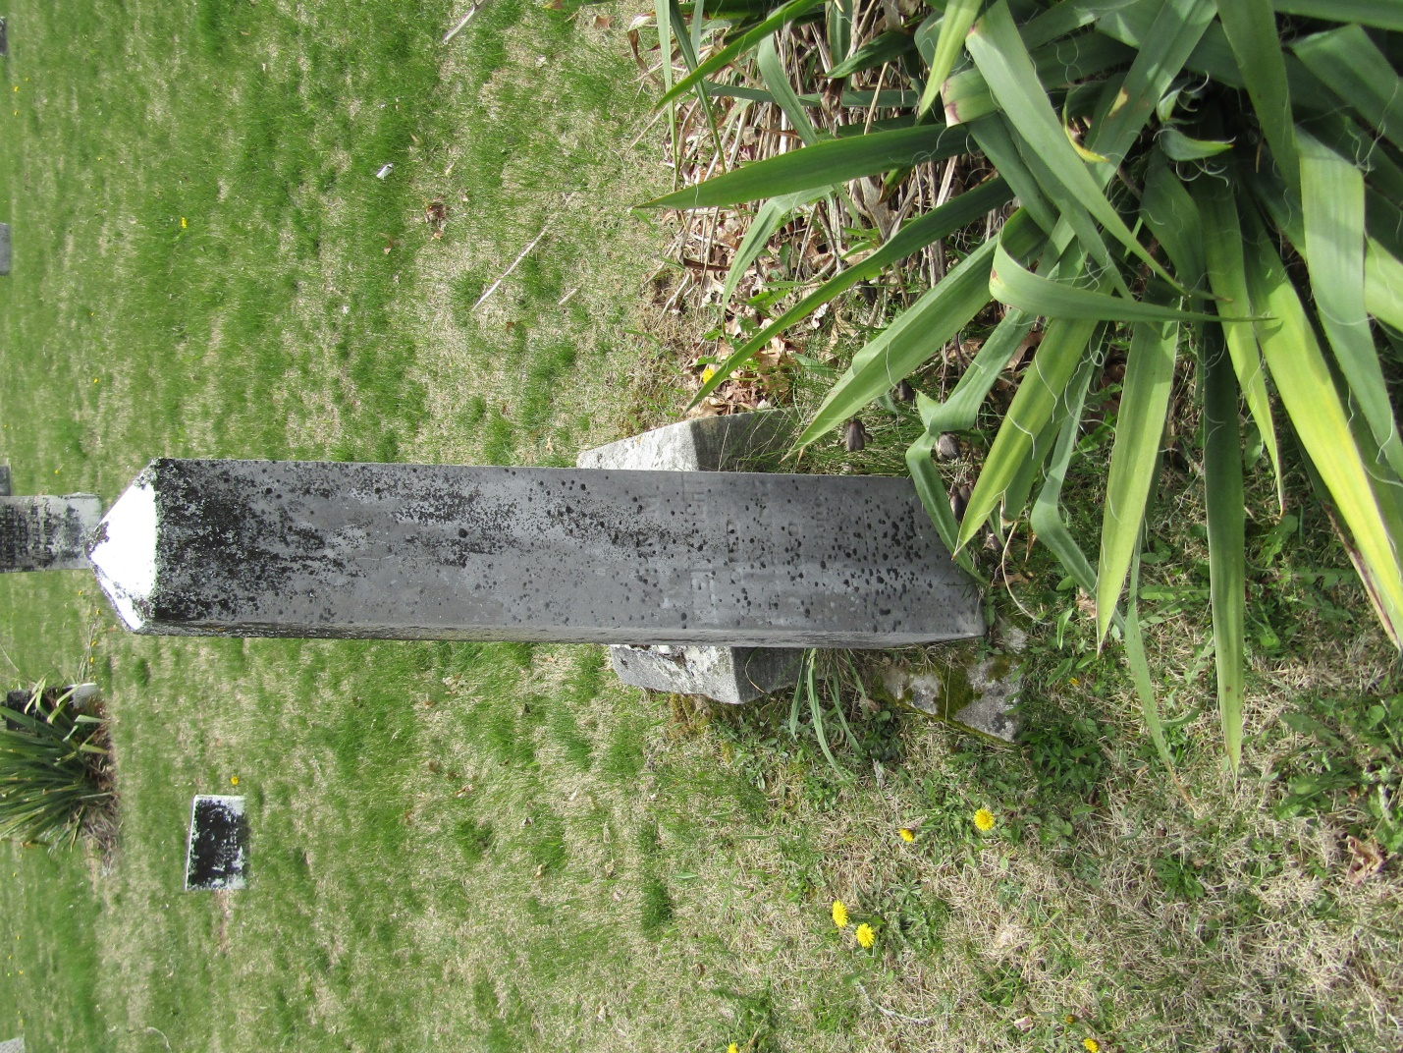

Johann Michael Kleinknight (Kleinknecht)) from tree Payne, Nichols, Agnew, Goodgion Family Tree

Birth 24 Oct OR 26 Oct 1794 Haubersbronn, Rems-Murr-Kreis, Baden-Württemberg, Germany
Marriage 1821 Baltimore, Maryland, USA
Residence 1860 Bluffton, Wells, Indiana, USA
Death 23 Feb 1867 Bluffton, Wells, Indiana, USA
Father Johann Michael Kleinknecht (1762-1840)
Mother Agnes Maria Haft (Born 1761)
Spouse Anna M Isenhart Eisenhardt (1788-1859)

