Anna (Shrock) Kleinknight
July 24, 1860 – January 31, 1934

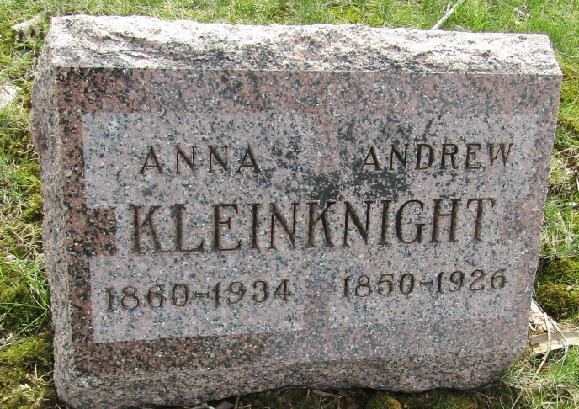

Uniondale Woman Claimed By Death
Mrs. Andrew Kleinknight Dies Wednesday Night of Heart Attack

Mrs. Andrew Kleinknight, 73, life-long resident of Wells County, died at 11:45 Wednesday night at her home at Uniondale. She had been ill the past week following a heart attack.
Born in Wells County on July 24, 1860, the deceased was a daughter of John E. and Jemima Craft Schoch. Her marriage took place at Ossian on Oct. 17, 1885. He preceded her in death on May 14, 1926.
Surviving are eight children, Mrs. Chester Osborn, Uniondale, Charles F. Kleinknight, Jackson, Mich.; Mrs. Jesse Daugherty, Uniondale; Mrs. Hugh Sturgeon, Bluffton; Mrs. Earl Lyons and Mrs. Robert Girod, Fort Wayne; and Chalmer E. Kleinknight and Clifford A. Kleinknight, Ossian. One sister, Mrs. Katherine Chapman, Findlay, O., and a brother, John E. Schoch, Elkhart, also survive.
Mrs. Kleinknight was a member of the United Brethren Church.
Funeral services will be held at 2 o'clock Saturday afternoon at the Uniondale Lutheran Church, in charge of Rev. G. A. Snider, Markle, assisted by Rev. H. L. Walmsley. Burial will be in the Murray Cemetery.

Bluffton Evening News Banner, Wells County, Indiana
Thursday, February 01, 1934

**
Indiana, U.S., Death Certificates, 1899-2017

Name Mrs Anna Kleinknight
[Mrs Anna Shrock]
Gender Female
Race White
Marital Status Widow
Age 73
Birth Date 24 Jul 1860
Birth Place Wells County, Indiana
Death Date 31 Jan 1934
Death Place Union, Wells, Indiana, USA
Death Registration Date 1934
Father John Shrock
Mother Jemima Craft
Spouse Andrew Kleinknight
Informant Mrs. Chester Osborn; Uniondale, Indiana
Burial February 3, 1934; Murray Cemetery

