Anna (Isenhart) Kleinknight
November 30, 1787 – January 20, 1859

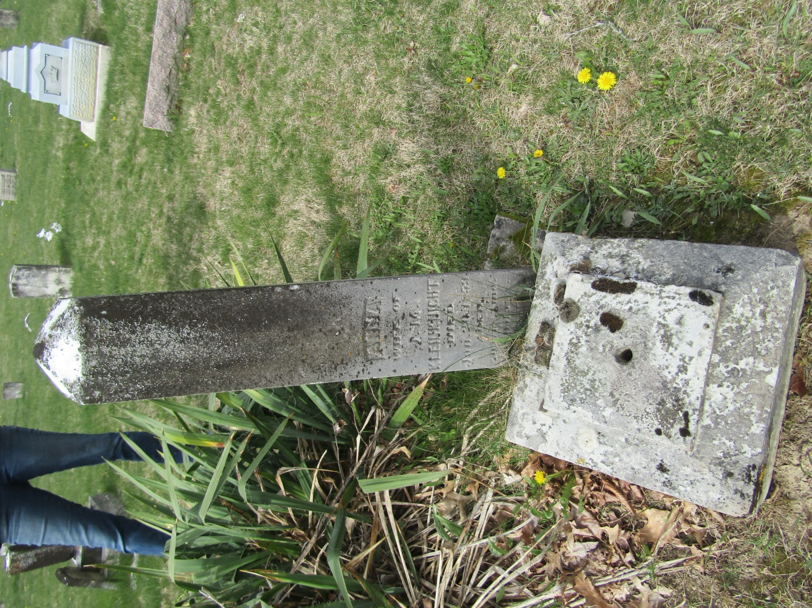

Anna M Isenhart Eisenhardt from tree Stoner/Risser/Clark/Jackson

Birth 30 Nov 1787 Baden-Württemberg, Germany
Marriage 1821 Baltimore, Maryland, USA
Residence 1850 Wells, Indiana, USA
Death 20 Jan 1859 Wells, Indiana, USA
Spouse John Michael Kleinknight Kleinbensht (1794-1867)

