Andrew Kleinknight
August 1, 1850 – May 14, 1926

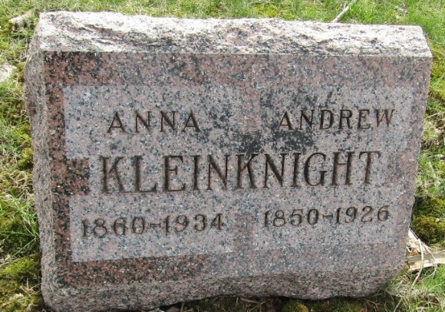

Andrew Kleinknight To Be Buried Sunday
Funeral Services Will Be Held At 2 O'clock At Pugney
Burial At Murray

Funeral services for Andrew Kleinknight, 75, who died of paralysis Friday afternoon at 3:05 o'clock at his home 1 mile west of Murray, will be held Sunday afternoon at 2 o'clock at the Pugney Church. Burial will be at Murray.
Mr. Kleinknight had been sick for six weeks, becoming bedfast four weeks ago. Last Sunday afternoon he suffered a paralytic stroke, the first he had ever suffered, which caused his condition to become extremely critical. Although he was unable to talk following the stroke it is thought he recognized members of the family and what was taking place. On Wednesday he lapsed into unconsciousness.
Mr. Kleinknight was born in Crawford County, Ohio, August 1, 1850, a son of Jacob Kleinknight and Elizabeth Miller Kleinknight. His marriage to Anna Schoch, who survives, took place in this county forty years ago last October.
Children surviving are Mrs. Chester (Bessie) Osborne, Uniondale; Charles Kleinknight, Bluffton; Mrs. Jesse Dougherty, north of Bluffton; Mrs. Hugh Sturgeon, Bluffton; Mrs. Earl Lyons, Fort Wayne; Chalmer Kleinknight, Fort Wayne; Mrs. Robert Girod, Fort Wayne; Clendon and Cliffton Kleinknight, both at home.
Five sisters are Mrs. Ellen Burnison, Detroit; Mrs. George Beagal, Fostoria, O.; Mrs. John Heckley, Tocsin; Mrs. Lydia Beck, Tocsin; Mrs. Andrew Lash, Tocsin.
Mr. Kleinknight became a member of the U. B. Church at Gallion, Ohio.

Bluffton Evening News, Wells County, Indiana
Saturday, May 15, 1926

