Albert C. Kleinknight
November 11, 1859 – June 17, 1881

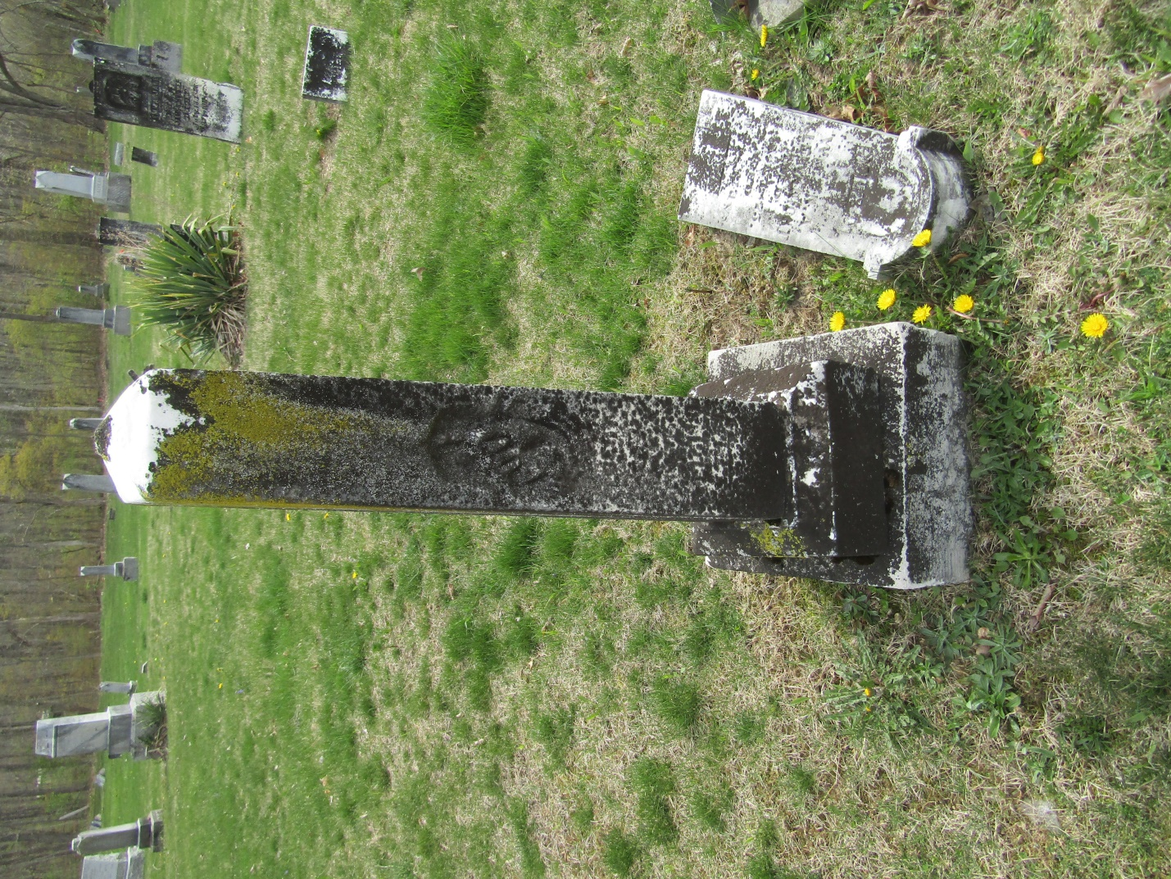

Albert C Kleinknight from tree Stoner/Risser/Clark/Jackson

Birth 11 Nov 1859 Wells Co IN
Residence 1880 Wells, Indiana, USA
Death 17 Jun 1881
Father William Frederick Kleinknight (1830-1903)
Mother Nancy Amrette Richey (1833-1909)

