Sarah Ellen (Mills) Kleinknecht
July 23, 1852 – December 10, 1915

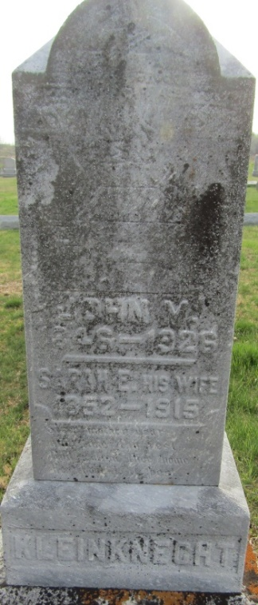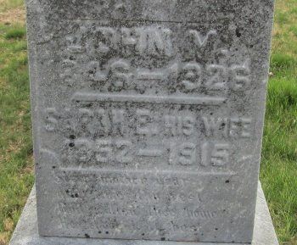

Sarah Ellen Klinknight
in the Indiana, U.S., Death Certificates, 1899-2017

Name Sarah Ellen Klinknight
[Sarah Ellen Mills]
Gender Female
Race White
Marital Status Married
Age 63
Birth Date 23 Jul 1852
Birth Place Ohio
Death Date 10 Dec 1915
Death Place Kingsland, Wells, Indiana, USA
Death Registration Date 1910-1919
Father Samuel Mills
Mother Mageline Bender
Spouse John Klinknight
Informant John Klinknight; Kingsland, Indiana
Burial December 13, 1915; Murray Cemetery

