Jacob Kleinknecht
January 21, 1822 – May 2, 1886

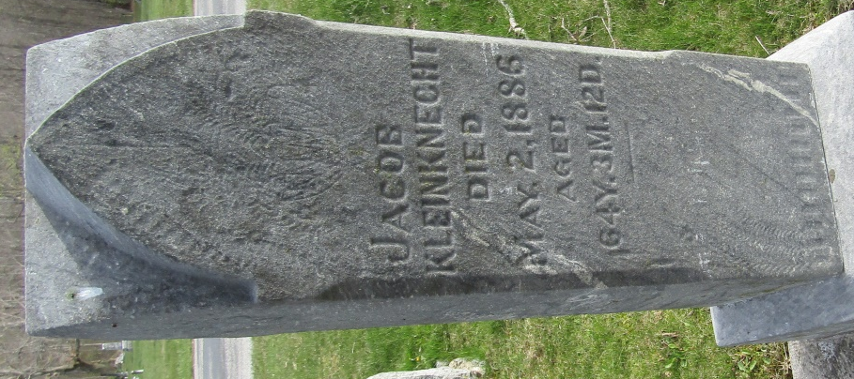

Jacob Kleinknecht from tree Bowlus/Bullis-Barlekamp/Urie-Hunter family tree

Birth 21 Jan 1822 Pennsylvania, USA
Marriage 29 Oct 1846 Crawford, Coshocton, Ohio, USA
Residence 1880 Wells, Indiana, USA
Death 2 May 1886 Bluffton, Wells, Indiana, USA
Father John Michael Kleinknight (1794-1867)
Mother Anna M Isenhardt (1787-1859)
Spouse Elizabeth Miller Kleinknecht (1825-1895)

