Eva V. (Murphy) Kleinknecht
February 20, 1887 – July 10, 1935

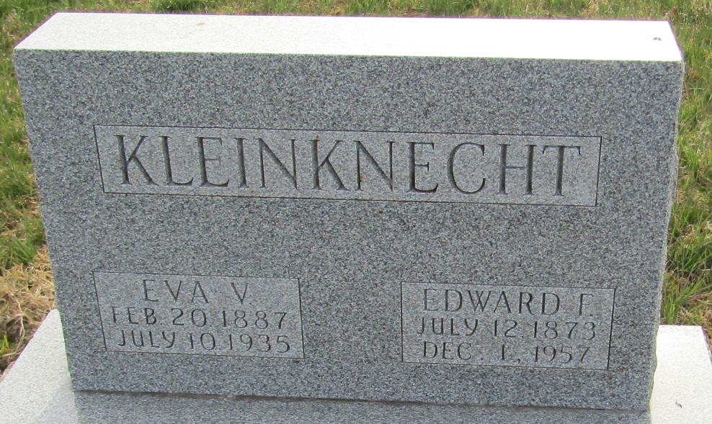

Eva Kleinknecht
in the Indiana, U.S., Death Certificates, 1899-2017

Name Eva Kleinknecht
[Eva Murphy]
Gender Female
Race White
Marital Status Married
Age 48
Birth Date 20 Feb 1887
Birth Place Massachusetts, USA
Death Date 10 Jul 1935
Death Place Fort Wayne, Allen, Indiana, USA
Death Registration Date 1935
Father James Murphy
Mother Unknown
Spouse E F Kleinknecht
Informant E. F. Kleinknecht; Ossian, Indiana
Burial July 13, 1935; Murray Cemetery

