Edward F. Kleinknecht
July 12, 1873 – December 1, 1957

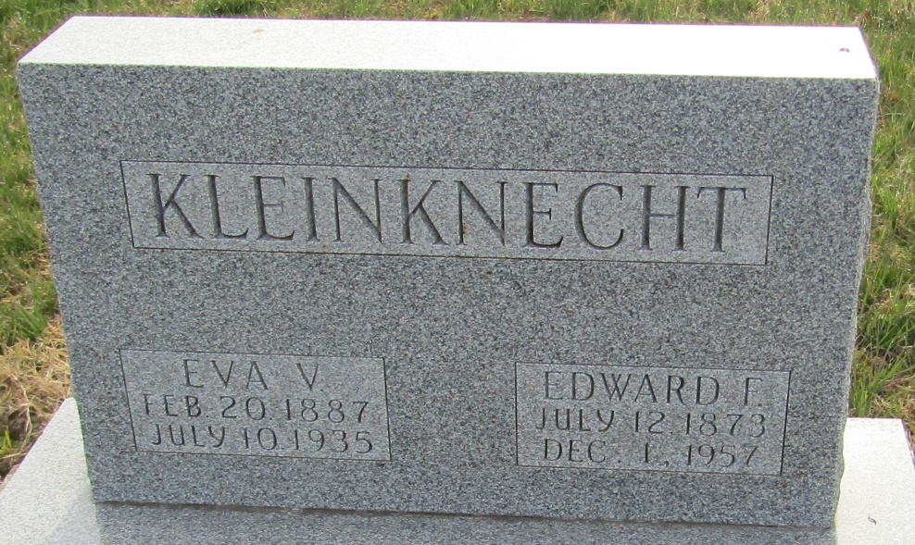

Edward Kleinknecht Is Taken By Death

Edward F. Kleinknecht, 84, of Kingsland, died Sunday morning at a Bluffton rest home after an illness of two years. He was a member of the Kingsland Methodist Church.
Surviving are two daughters, Mrs. Honor Harris and Pallas Wiebke of Kingsland, and a sister. Mrs. Maude Tyler of Stockton, Calif.
Services will be held at 2:30 p.m. Tuesday at the Thoma Funeral Home in Bluffton, the Rev. Homer Studebaker officiating. Burial will be in the Murray Cemetery.

Decatur Daily Democrat, Adams County, Indiana
Monday, December 2, 1957
**

Indiana, U.S., Death Certificates, 1899-2017

Name Edward F. Kleinknecht
Gender Male
Race White
Marital Status Widowed
Age 84
Birth Date 12 Jul 1873
Birth Place Indiana
Death Date 1 Dec 1957
Death Place Bluffton, Wells, Indiana, USA
Death Registration Date 1957
Father John M. Kleinknecht
Mother Sarah Ellen Mills
Informant Honor Harris; daughter; Kingsland, Indiana
Burial December 3, 1957; Murray Cemetery; Murray, Indiana

