Mary (Johnston) Kirkpatrick
March 23, 1796 – September 4, 1858

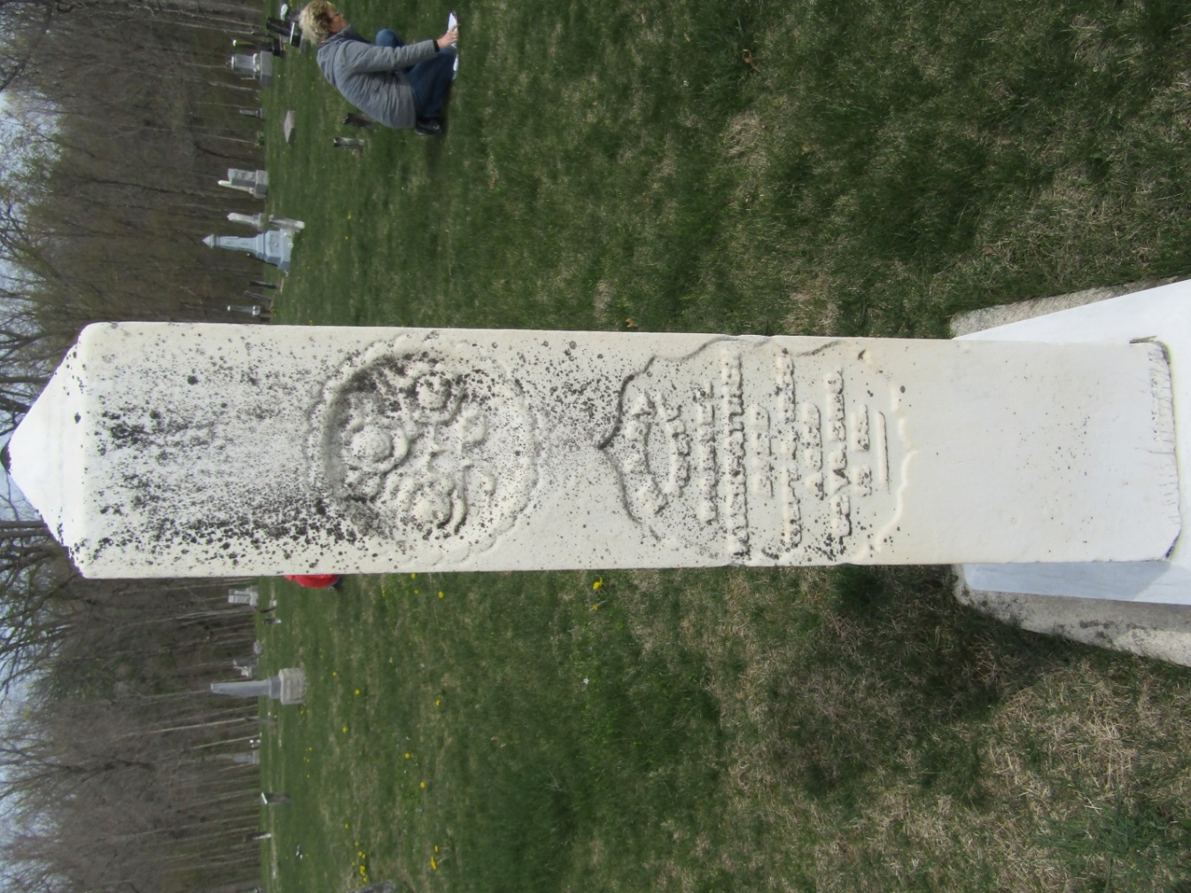

Mary Johnston from tree Smith/Rinehart Family Tree

Birth 23 Mar 1796 Pennsylvania, USA
Marriage 25 Feb 1819 Stark, Ohio, USA
Residence 1860 Island Creek, Jefferson, Ohio, USA
Death 4 Sep 1858 Wells, Indiana, USA
Father James Johnston
Spouse Daniel Kirkpatrick (1793-1858)

