Mary Jane Kirkpatrick
May 31, 1824 – September 8, 1857

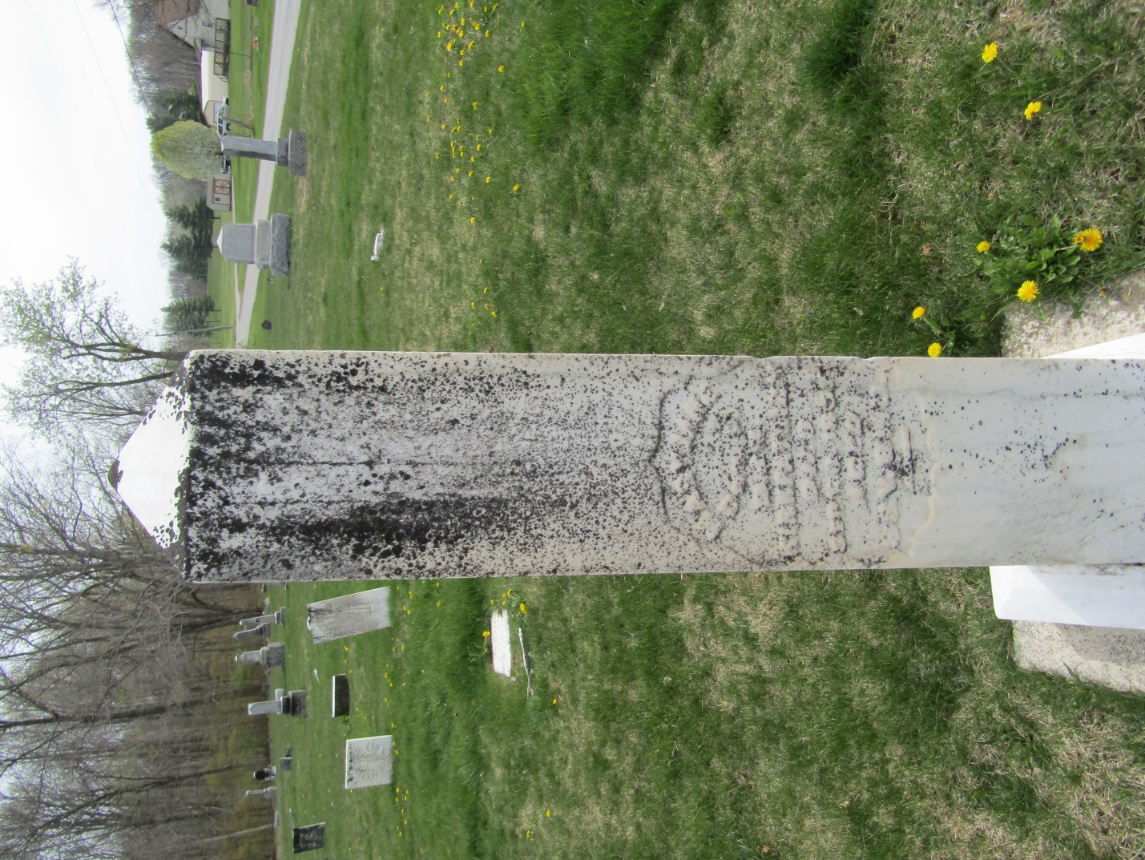

Mary Jane Kirkpatrick from tree Dodge/Rose Family Tree

Birth 31 May 1824 Wayne, Ohio, USA
Residence 1850 Franklin, Wayne, Ohio, USA
Death 8 Sep 1857 Wells, Indiana, USA
Father Daniel Kirkpatrick (1793-1858)
Mother Mary Johnston (1796-1858)

