Samuel J. Kimmel
December 7, 1862 – August 19, 1931

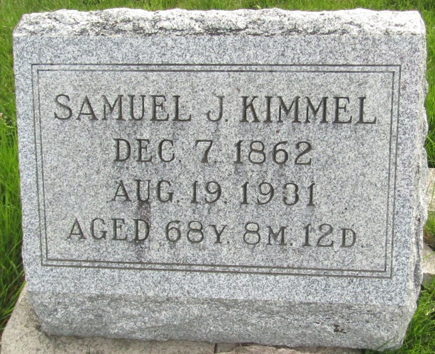

SAMUEL KIMMEL DIES AT TOCSIN
Funeral Services Will Be At Tocsin Friday Morning

Samuel J. Kimmel, 68, a resident of Tocsin for over sixty years, died at his home this morning at 12:30 following an illness of six months of stomach trouble.
He was born in Van Wert County, Ohio, a son of Kahn and Martha Roop Kimmel, and was 68 years, 8 months and 12 days of age at the time of his death.
He came to Tocsin when he was a small boy and had made his home there the rest of his life. He never married.
He was the last surviving member of his immediate family. His nearest surviving relatives are four cousins, Mrs. W.D. Plummer, and Mrs. T.M. Hall, both of Tocsin; Paris Jones, near Ossian, and Mrs. Rosa August, Willshire, Ohio.
The body was taken to the Elzey undertaking parlors at Ossian and will remain there until Thursday morning when it will be taken to the W.D. Plummer home. Funeral services will be held at the Tocsin U.B. church at 2 o'clock Friday afternoon in charge of Rev. A.S. Elzey. Burial will be in the Murray Cemetery.

Evening News Banner, Wells County, Indiana
Wednesday, August 19, 1931

**
Indiana, U.S., Death Certificates, 1899-2017

Name Samuel J. Kimmel
Gender Male
Race White
Marital Status Single
Age 68
Birth Date 7 Dec 1862
Birth Place Ohio
Death Date 19 Aug 1931
Death Place Tocsin, Wells, Indiana, USA
Death Registration Date 1931
Father Kahn Kimmel
Mother Martha Roop
Informant Mrs. W. D. Plummer; Tocsin, Indiana
Burial August 21, 1931; Murray Cemetery

**
Kimmel's will dated 11 June 1931:
I, Samuel J. Kimmel being of sound mind hereby make this my last will and teatament [sic].
Item One. I hereby direct that all expenses of my estate be first paid out of my personal property.
Item two. I hereby bequeath all the balance of my personal estate to Rosa August and Roxy Stuttler in the following proportions Two-thirds to Rosa August and one-third to Roxy Stuttler
Item three. I hereby appoint Tida E. Plummer as Executor of this my last will and testament to serve without bond.
Samuel J. Kimmel Seal
Signed and sealed in our presence and in the presence of each other this 11th day of June, 1931
Irvin W. Wasson, Milton Wibel

