Martha E. (Roop) Kimmel
February 2, 1844 – July 23, 1903

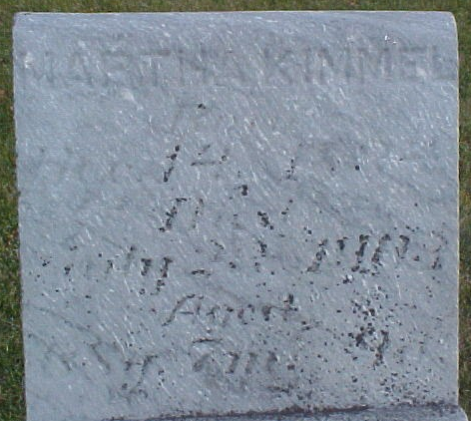

Mrs. Matthew (sic) Roop died at her home in Tocsin yesterday afternoon, after a long period of illness.
Her husband is dead, and her demise now leaves their one child, a boy, an orphan.
The funeral will be held at ten o'clock tomorrow, from the M.E. Church west of Tocsin.

Evening News, Bluffton, Wells County, Indiana
Friday, July 24, 1903
Page 3, Column 8

**
Last Saturday at Murray occurred the burial of Mrs. Martha Roop, whose death had been Thursday evening at her home in Tocsin. She had long been an invalid, having suffered for years from rheumatism.
A son, a man of thirty years who has been her only cheer for many years, survives the deceased lady.

Bluffton Banner, Wells County, Indiana
July 29, 1903

**
Indiana, U.S., Death Certificates, 1899-2017

Name Matha E Kimell
[Matha E Roop]
Gender Female
Race White
Marital Status Widowed
Age 59
Birth Date 2 Feb 1844
Birth Place Van Wert, Ohio
Death Date 23 Jul 1903
Death Place Jefferson, Wells, Indiana, USA
Death Registration Date 1903
Father John Roop
Mother Elizebeth Souerds
Spouse Con Kimmel
Informant Samuel Kimmel; Tocsin, Indiana
Burial July 25, 1903; Murray Cemetery

**
Indiana Marriage Collection, 1800-1941

Name: Conrad Kemerial
Spouse Name: Martha E. Roop
Marriage Date: 12 Dec 1861; Marriage County: Adams
Adams County, Indiana Index to Marriage Records 1845 - 1920 Inclusive Vo, W. P. A. Original Record Located County Clerks Off; Book: B, OS Page: 357

