Mary Matilda (Young) Keller
February 28, 1804 – July 18, 1865

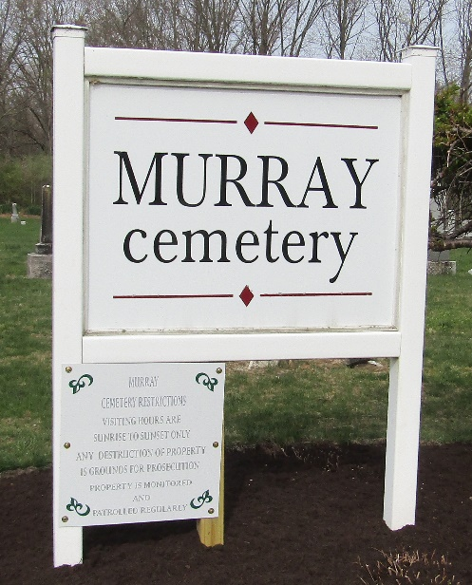

Mary Matilda Young from tree King Family Tree

Birth 28 Feb 1804 Pennsylvania, Somerset, Pennsylvania, USA
Residence 1860 Wells, Indiana, USA
Death 18 Jul 1865 Wells, Indiana, USA
Spouse William Keller (1799-1877)

