George Young Keller
April 8, 1833 – August 10, 1903

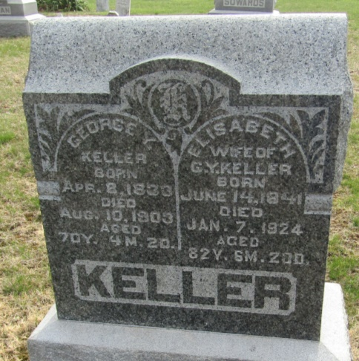

George Y Kelles
in the Indiana, U.S., Death Certificates, 1899-2017

Name George Y Keller
Gender Male
Race White
Marital Status Married
Age 70
Birth Date 8 Apr 1833
Birth Place Pennsylvania
Death Date 10 Aug 1903
Death Place Lancaster, Wells, Indiana, USA
Death Registration Date 1903
Father Wm Keller
Mother Unknown
Spouse Elizebeth Lash
Informant Family; Bluffton, Indiana
Burial August 12, 1903; Murray Cemetery;

**
George Young Keller from tree Hixon Family Tree

Birth 8 Apr 1833 Pennsylvania, Somerset, Pennsylvania, USA
Marriage 1 Sep 1859 Wells, Indiana, USA
Residence 1900 Wells, Indiana, USA
Death 10 Aug 1903 Bluffton, Wells, Indiana, USA
Father William Keller (1799-1877)
Mother Mary Matilda Young (1804-1865)
Spouse Elizabeth Lash (1841-1924)

