Elisabeth (Lash) Keller
June 14, 1841 – January 7, 1924

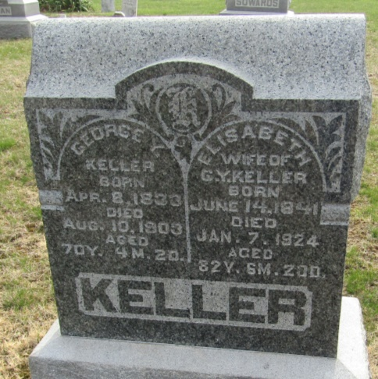

Elizabeth Lash Keller
in the Indiana, U.S., Death Certificates, 1899-2017

Name Elizabeth Lash Keller
[Elizabeth Lash]
Gender Female
Race White
Marital Status Widow
Age 82
Birth Date 14 Jun 1841
Birth Place Greene County, Ohio
Death Date 7 Jan 1924
Death Place Bluffton, Wells, Indiana, USA
Death Registration Date 1924
Father Isaac Lash
Mother Matilda Fisher
Spouse Geo Keller
Informant Mrs. Jeff Prough; Bluffton, Indiana
Burial January 10, 1924; Murray Cemetery

