Clarence Kahn
October 9, 1916 – October 15, 1922

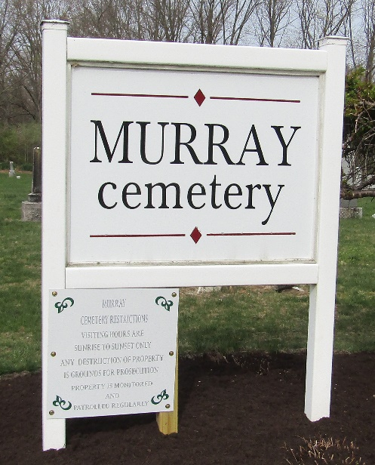

BOY KILLED BY ERIE PASSENGER TRAIN SUNDAY
Clarence Kahn, Age 6 Years, Was Almost Instantly Killed Here
PLAYING ON TRACKS
Was Rolling Buggy Wheel Across Tracks and Did Not See Train

While happy at play and unconscious of any danger, Clarence Kahn, six-year-old son of Mr. and Mrs. Leo Kahn, was struck and almost instantly killed by an east bound Erie passenger train at the Tenth Street crossing, about 3:30 o'clock Sunday afternoon. The lad lived only fifteen minutes following the accident.
The Kahn home is located a few feet south of the railroad tracks on Tenth Street. The boy had been playing in the street, rolling an old buggy wheel. He had rolled it to the north side of the tracks and turned around to return toward his home. Just as he stepped upon the tracks, the passenger train struck him. The train ran on to the station a few blocks farther and then backed up to the crossing where the boy had been struck.
A physician was summoned but the boy lived only a very short time after he arrived. The lad’s skull had been fractured and the scalp badly lacerated. He was bruised about his body. There were no obstructions along the tracks at the point where the accident occurred, which might have obstructed the boy's view of the oncoming train. It is the general supposition that the boy was thinking only of his play and failed to look down the track before crossing. Another passenger train had just passed the crossing a few minutes previous to the time of the accident, and the boy may have thought that there would be no more along for some time. A little sister was also playing in the street when the boy was killed but his parents did not see the accident.
Mrs. Kahn stated today that they did not hear the train give a signal for the crossing.
Clarence Kahn was born in Decatur, October 9. 1916. His father is a junk dealer and common laborer.
Clarence is survived by his father and mother, two brothers, one sister, and one half-brother.
Funeral services will be held from the United Brethren Church at 1:30 o’clock Tuesday afternoon, the Rev. B. F. Dotson, pastor, officiating. Burial will be held in the St. Paul Cemetery (sic), near Bluffton, Ind.

Decatur Daily Democrat, Adams County, Indiana
Monday, October 16, 1922
**
Indiana, U.S., Death Certificates, 1899-2017

Name Clarence Kahn
Gender Male
Race White
Marital Status Single
Age 6
Birth Date 9 Oct 1916
Birth Place Adams Co Indiana
Death Date 15 Oct 1922; hit by train
Death Place Decatur, Adams, Indiana, USA
Death Registration Date 1922
Father Leo Kahn
Mother Dora Smith
Informant Leo Kahn; Decatur, Indiana
Burial October 17, 1922; Murray Cemetery

