Wilbert Jones
August 24, 1893 – November 12, 1896

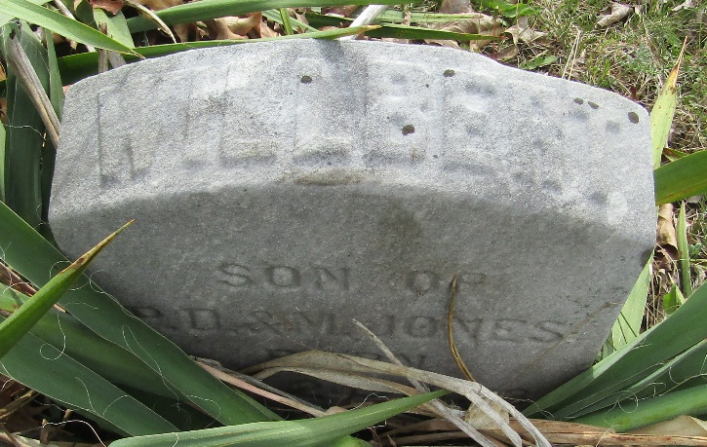

Wilbert Jones from tree Karen Crowl Patterson
Birth 24 Aug 1893 Wells, Indiana, USA
Death 12 Nov 1896 Wells, Indiana, USA
Father Paris Dunning Jones (1871-1951)
Mother Martha "Mattie" Crowl-Jones (1871-1898)

