Paris Dwight Jones
April 24, 1871 – February 18, 1951

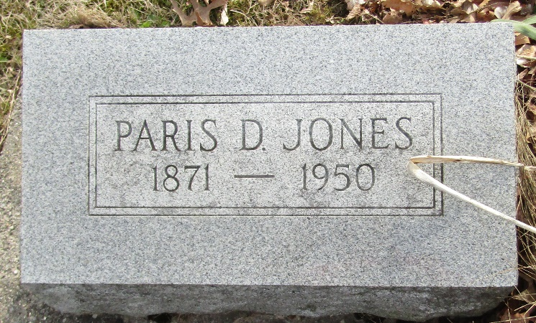

Paris D. Jones is Claimed by Death

Paris D. Jones, 79, who resided two- and one-half miles southeast of Ossian, died at 12:05 Sunday morning at the Davis Funeral Home, southeast of Bluffton after a serious illness of six weeks.
The decedent was born April 24, 1871, in Wells County to Cornelius and Angeline Roop Jones.
Surviving beside the widow, the former Evelyn Schnurbush, are three daughters, Mrs. Harry Bell, Jr., of Craigville, Mrs. Merlon Ferrell of Haverhill, Massachusetts, and Mrs. Paul Beerman of Fort Wayne, Route 10, and seven grandchildren.
The body has been removed to the Elzey and Son Funeral Home where friends may call. Funeral services will be held at 2 pm Tuesday at the funeral home with Rev. Howard Small officiating. Burial will be in the Murray Cemetery.

Bluffton News-Banner, Wells County, Indiana
February 19, 1951

