Martha “Mattie (Crowl) Jones
March 21, 1871 – August 29, 1898

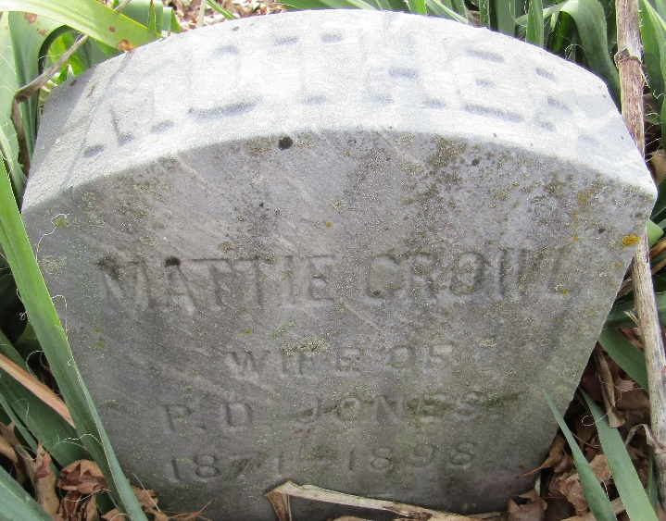

Mrs. Paris Jones, daughter of John D. Crowl, died on Monday morning from consumption. A husband and one child, a little girl of four years, her aged father and many friends and relatives have cause to mourn her early departure. Funeral at Emmauel on Tuesday, conducted by her pastor, Rev. H. C. Smith. Interment in Murray Cemetery.

Bluffton Chronicle, Wells County, Indiana
Wednesday, August 31, 1898
**
Martha Crowl was born March 21, 1871. She was the daughter of John D. and Mary Crowl. She was united in marriage to Paris Jones, Dec. 1st, 1892. To this union was born three children. Two sons preceded her to the spirit world. She departed this life August 29th, 1898, aged 27 years, 5 month and 2 days.
She leaves a husband and daughter, father, seven brothers and three sisters to mourn her loss.
The funeral services were held in Emmaus M. E. church by the writer to a large and sympathetic audience.
Respectfully, H. C. Smith
She is not death, the one we mourn
In deep, but chastened sorrow.
Her spirit has but gone to dwell
Where ours may be tomorrow.
There cometh over in our grief,
Amid our sighs and weeping.
The blessed and consoling thought
She is not dead, but sleeping.
Each day does nature's voice proclaim
The old, but wondrous story.
Of how the sun must set in gloom,
To rise again in glory.
The seed must mold in the dust
To bring a joyous reaping.
Then let us wait the harvest day,
She is not dead, but sleeping.

**
Martha "Mattie" Crowl-Jones from tree Karen Crowl Patterson
Birth 1871 Wells, Indiana, USA
Residence 1880 Wells, Indiana, USA
Marriage 1 Dec 1892 Wells, Indiana, USA
Death 3 Oct 1898 Wells, Indiana, USA
Father John Daniel Crowl (Crowell) (1821-1899)
Mother Mary Ann Dillon (1829-1880)
Spouse Paris Dunning Jones (1871-1951)

