Lewis T. Johnson, Rev.
September 30, 1832 – March 7, 1901

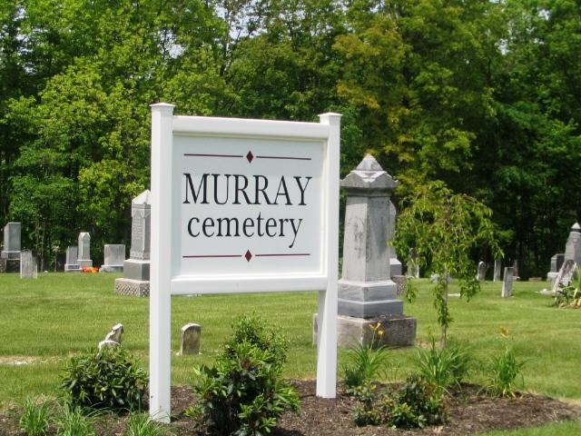
Photo by Barbara Baker Anderson

Rev. L. T. Johnson, a retired U. B. minister, died at noon at his home near Tocsin Thursday. He had preached for many years on the Tocsin circuit but retired ten years ago because of failing health. Dropsy was the cause of death. He leaves a widow, his fourth wife, and a number of children. The funeral occurred Saturday with burial at Murray.

Bluffton Chronicle, Wells County, Indiana
Wednesday, March 13, 1901

**
Rev. L. T. Johnson was born in Fairfield County, Ohio, September 30, 1832, died at Tocsin, Wells County, Indiana, March 7, 1901, aged 68 years, 7 months and 7 days. He has been a great sufferer for the past three years with a complication of diseases which confined to the house most of the time. He was converted at the age of 17, in Hocking County, Ohio, and lived a consistent Christian until the Master called him home.
When the tocsin of war sounded, he responded to his country's call, and volunteered as a soldier, and when his service in the army closed, he engaged in teaching school in Mercer County, Ohio. When he felt the call to the Ministry, he, like one of old, said, "Here am I, send me", so at a conference held by the U. B. church in Union County, Ohio, in 1869, he was licensed to preach the gospel for 20 years. In the active work he was called sometimes to travel fields where his support was meagre yet with that self sacrificing and unflinching faith he accepted the work assigned him. During his ministry he received nearly twelve hundred into the church, and preached a great number of funerals, sometimes going as far as 20 miles to preach funerals. For the past twelve years he has retired from the active work on account of failing health.
In early manhood he was united in marriage to Miss Amanda Web, of Mercer County, Ohio. To this union were born four children, two having died in early life, and two living, Elihu, who lives near Willshire, Ohio, and Shelby, who is in the ministry, and is located now at Wren, Ohio. After 13 years of married life his home was visited by death and his companion was taken.
He was again married to Miss Angeline Cartwright, of the same county. To this union were born two children, one dying in infancy, and Melville, who lives in Tocsin. Again, after a married life of but three short years, the angel of death visited the home and claimed the companion, leaving the home desolate. He again united in marriage to Miss Mary Bender, of Wells County, Ind. After another short married life of less than one year, the home was left without a mother's care, death having claimed the wife and an infant child. On the 6th day of October, 1878, he was married to Miss Leah E. Schoch, of Wells County, Ind., who still she survives him, and tenderly cared for him in his declining years and afflictions. To this union two children were born, one now dead, the other, Walter, living at home with his mother.
He leaves a wife, four children, two brothers who live in Mercer County, Ohio, and a number of grandchildren, relatives and friends to mourn, but their loss is his gain. The wife, all the children and one brother were at his bedside when he passed away.
The funeral was held at Tocsin, Saturday, March 9th, conducted by the writer, assisted by Rev. Hutchinson, his pastor, and Rev. Carter, of Craigville. We laid his remains in the Murray Cemetery to await the Resurrection morn.
Rev. H. C. Smith

Bluffton Chronicle, Wells Co., Indiana
Wednesday, March 20, 1901

**
Lewis T. Johnson from tree SMITH YOUNG LANE FILLENWARTH WYCKOFF
Birth 30 Sep 1832 Fairfield, Ohio, USA
Marriage 29 Sep 1877 Wells, Indiana, USA
Residence 1900 Wells, Indiana, USA
Death 7 Mar 1901 Wells, Indiana, USA
Father Enoch George Johnson (1805-1878)
Mother Hanor Elder (1806-1864)
Spouse Amanda Ann Webb (Born 1837)
Spouse Phoebe Angeline Courtwright (Born 1847)
Spouse Leah E Schoch (1853-1924)
9988 People 10 Records 11 Sources

