Mearl Janssen
October 1, 1906 – October 10, 1906

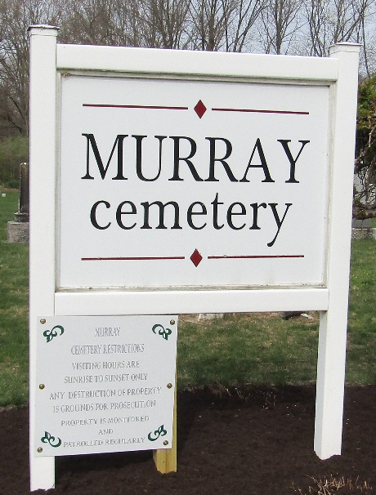

Mearl Janssen
in the Indiana, U.S., Death Certificates, 1899-2017
Name Mearl Janssen
Gender Male
Race White
Marital Status Single
Age 0
Birth Date 1 Oct 1906
Birth Place Indiana
Death Date 10 Oct 1906
Death Place Forman, Wells, Indiana, USA
Death Registration Date 1906
Father Wm Janssen
Mother Emily Kratz
Informant Wm. Janssen; Tocsin, Indiana
Burial October 12, 1906; Lutheran Cemetery

