Sophia Hunt
October 6, 1913 – February 11, 1914

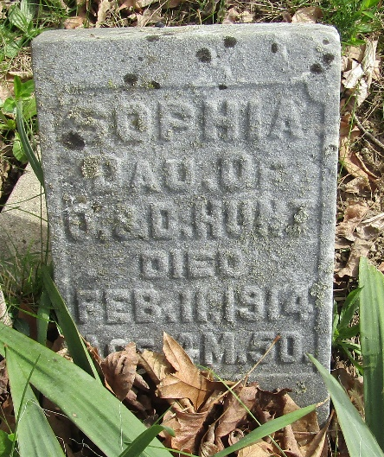

No further information found at this time

