Oscar Hunt
- February 3, 1900

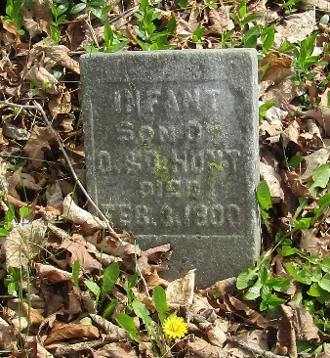

Oscar Hunt
in the Indiana, U.S., WPA Death Index, 1882-1920
Name Oscar Hunt
Date Feb 03, 1900
Location Wells County
Age Infant
Gender Male
Race White
Source location County Health Office, Bluffton
Source notes The source of this record is the book H-2 on page 18 within the series produced by the Indiana Works Progress Administration

