Mamie Hunt
February 7, 1910 – February 10, 1910

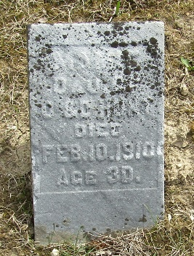

Mannie Hunt
in the Indiana, U.S., Death Certificates, 1899-2017
Name Mamie Hunt
Gender Female
Race White
Age 0
Birth Date 8 Feb 1910(sic)
Birth Place Wells County
Death Date 10 Feb 1910
Death Place Lancaster, Wells, Indiana, USA
Death Registration Date 1910
Father Oscar Hunt
Mother Dessie Nelson
Informant James Hunt; Tocsin, Indiana
Burial Not stated

