Infant daughter Hunt
April 16, 1902 – April 20, 1902

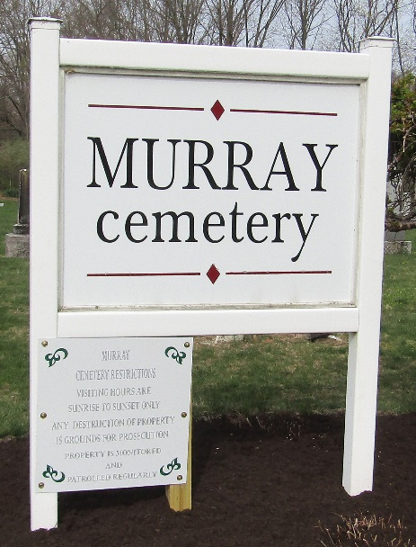

Infant Hunt
in the Indiana, U.S., Death Certificates, 1899-2017
Name Infant Hunt
Gender Female
Race White
Marital Status Single
Age 0
Birth Date 16 Apr 1902
Birth Place Wells County, Indiana
Death Date 20 Apr 1902
Death Place Lancaster, Wells, Indiana, USA
Death Registration Date 1902
Father Oscar Hunt
Mother Dessie Nelson
Informant Family; Bluffton, Indiana
Burial April 21, 1902; Murray Cemetery

