Noah Hower
June 13, 1845 – June 17, 1924

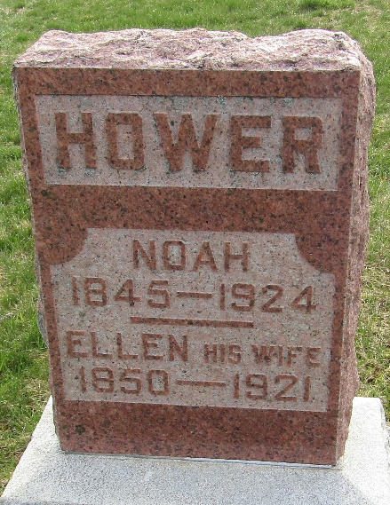

Noah Hower
in the Indiana, U.S., Death Certificates, 1899-2017
Name Noah Hower
Gender Male
Race White
Marital Status Widowed
Age 79
Birth Date 13 Jun 1845
Birth Place Piqua, Ohio
Death Date 17 Jun 1924
Death Place Harrison, Wells, Indiana, USA
Death Registration Date 1924
Father Andy Hower
Mother Not listed [Margaret Buroker]
Informant Harry Hower; Ossian, Indiana
Burial June 19, 1924; Murray Cemetery

