Eliza Ellen (Clowser) Hower
June 10, 1850 – May 7, 1921

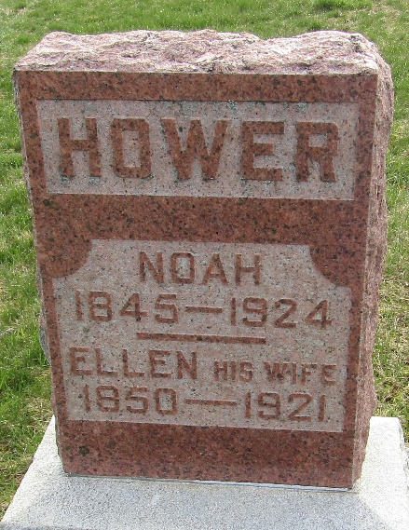

Eliza Ellen Hower
in the Indiana, U.S., Death Certificates, 1899-2017
Name Eliza Ellen Hower
[Eliza Ellen Clowser]
Gender Female
Race White
Marital Status Married
Age 70
Birth Date 10 Jun 1850
Birth Place Ohio
Death Date 7 May 1921
Death Place Lancaster, Wells, Indiana, USA
Death Registration Date 1921
Father John Clowser
Mother Sarah Schoch
Spouse Noah Hower
Informant Noah Hower; Craigville, Indiana
Burial May 9, 1921; Murray Cemetery

