Charles Clifton Howard
October 14, 1872 – June 12, 1906

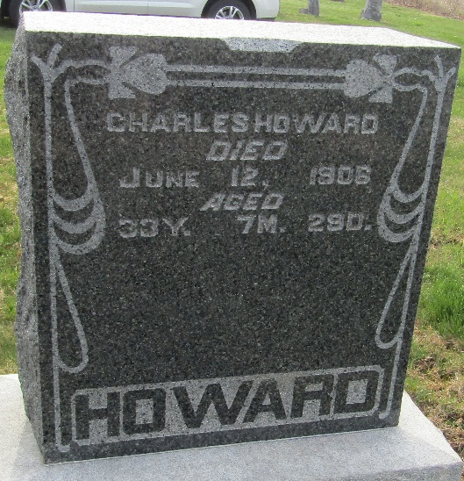

Charles Cliffton Howard from tree Pearls Of Yesteryear, Revisited...
Birth 14 Oct 1872 Indiana, USA
Marriage 7 Oct 1893
Residence 1900 Wells, Indiana, USA
Death 12 Jun 1906 Raton, Colfax, New Mexico, USA
Father Alfred Martin Howard (1838-1913)
Mother Jemima Cynisca McBride Warner Sale Howard (1846-1923)
Spouse Bird Eveline Bender Thornburg Howard Jones (1876-1966)

