Mary Ann (Perry) Hoover
December 12, 1859 – July 23, 1879

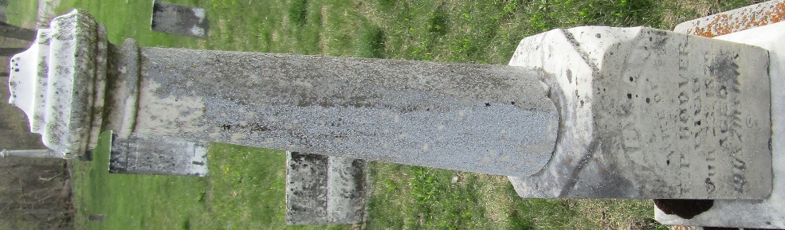

Mary Ann Perry from tree Manton Area Family Tree Project
Birth Feb OR May 1860 Wells, Indiana, USA
Residence 1870 Wells, Indiana, USA
Marriage 30 Sep 1875 Wells, Indiana, USA
Death 23 Jul 1879 Wells, Indiana, USA
Father Martin Perry (1807-1870)
Mother Elizabeth Nash (Born 1831)
Spouse Franklin Pierce Hoover (1852-1925)

