Jane M. (Nash) Hoover
October 8, 1841 – November 13, 1918

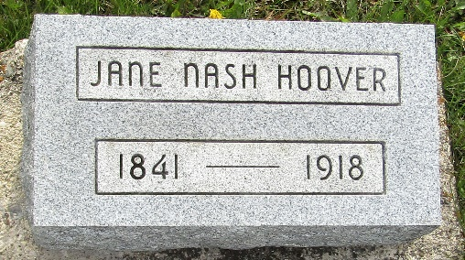

Jane M. Hoover
in the Indiana, U.S., Death Certificates, 1899-2017
Name
[Jane M. Hoover]
Maiden Name [Nash]
Gender Female
Race White
Marital Status Married
Age 77
Birth Date 8 Oct 1841
Birth Place Stark County, Ohio
Death Date 13 Nov 1918
Death Place Washington, Adams, Indiana, USA
Death Registration Date 1918
Father William Nash
Mother Lydia Borden
Spouse Levi Hoover
Informant ?essa Moore; Decatur, Indiana
Burial November 15, 1918; Murray Cemetery

