Elisabeth (McMurry) Hoopengardner
November 12, 1834 – September 14, 1871

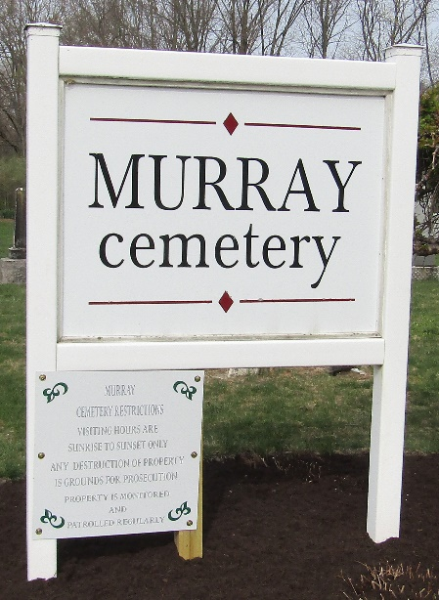

Elisabeth MacMurry from tree garvin/norman Family Tree
Birth 12 Nov 1834 Pennsylvania, USA
Residence 1870 Ossian, Wells, Indiana, USA
Death 14 Sep 1871 Indiana, USA
Father James McMurry (Born 1791)
Mother Elizabeth McMurry (Born 1793)
Spouse John Hoopengardner (1832-1909)
17000 People 5 Records 5 Sources

