Eliza E. Holley
July 10, 1832 – January 10, 1873

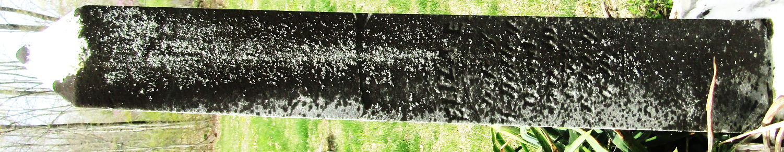

No further information found at this time

