Ethel M. (Martin) Holder
May 9, 1926 – May 13, 1982

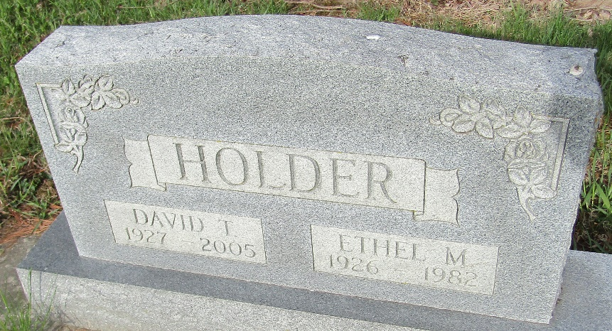

Ethel M. Holder
in the Indiana, U.S., Death Certificates, 1899-2017
Name Ethel M. Holder
[Ethel M. Martin]
Gender Female
Race Caucasian (White)
Marital Status Married
Age 56
Birth Date 9 May 1926
Birth Place Georgia
Death Date 13 May 1982
Death Place Bluffton, Wells, Indiana, USA
Death Registration Date 1982
Father Jasper Martin
Mother Luda Belle Wilson
Spouse David Holder
Informant David Holder; husband; Bluffton, Indiana
Burial May 17, 1982; Murray Cemetery; Murray, Indiana

