David T. Holder
June 9, 1927 – November 17, 2005

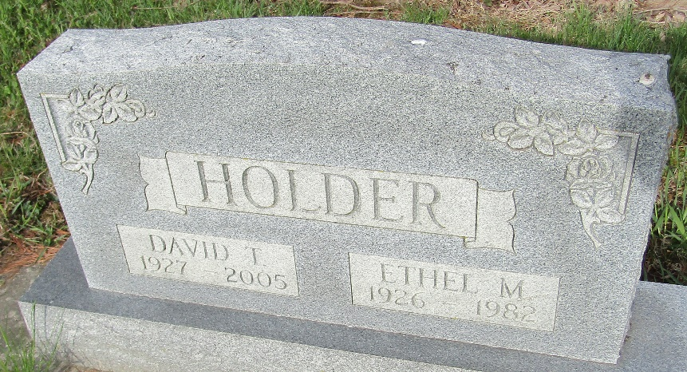

A former resident of Bluffton, David T. Holder, 78, of Geneva, died at 5:50 p.m. Thursday, Nov. 17, at his residence. Born in Adell, Ga., June 9, 1927, to John and Lela May Rechstroth Holder, he married the former Ethel M. Martin March 14, 1946, in Lafayette, Ga. She preceded him in death May 13, 1982.
An employee of Sterling Casting for 30 years, he retired in 1985. He was a member of the Eagles Lodge and the Moose Lodge in Decatur.
Survivors include three daughters, Mrs. Harold (Virginia) Williams, Evelyn Hall, and Dian Mahon, all of Bluffton; a half-brother, John Holder of Bluffton; two half-sisters, Joyce Fox, Bluffton, and Ruby Short, Anderson; nine grandchildren and 22 great-grandchildren. He was preceded in death by a daughter, Lelia Nickolson.
Services at Goodwin Memorial Chapel will be held at 10:30 a.m. Tuesday under the direction of Rev. David Knell. Burial will follow at the Murray Cemetery east of Murray. Calling Monday will be from 2 to 8 p.m. at the funeral home.

Bluffton News-Banner, Wells County, Indiana
Friday, November 18, 2005

