James M. Hockaday
March 28, 1831 – September 5, 1908

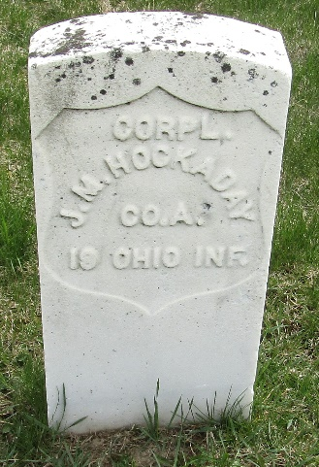

James M Hockaday
in the Indiana, U.S., Death Certificates, 1899-2017
Name James M Hockaday
Gender Male
Race White
Marital Status Widowed
Age 77
Birth Date 28 Mar 1831
Birth Place Pennsylvania
Death Date 5 Sep 1908
Death Place Ossian, Wells, Indiana, USA
Death Registration Date 1908
Father Wm Hochady
Mother Unknown
Spouse Mary
Informant Wm. Hockaday; Ossian, Indiana
Burial September 8, 1908; Murray Cemetery

**
U.S., Civil War Soldier Records and Profiles, 1861-1865
Name James M Hockaday
Enlistment Age 28
Birth Date abt 1833
Enlistment Date 10 Sep 1861
Enlistment Rank Private
Muster Date 10 Sep 1861
Muster Place Ohio
Muster Company A
Muster Regiment 19th Infantry
Muster Regiment Type Infantry
Muster Information Enlisted
Rank Change Date 1 Jan 1864
Rank Change Rank Corpl
Muster Out Date 24 Oct 1865
Muster Out Information Mustered Out
Side of War Union
Survived War? Yes
Title Official Roster of the Soldiers of the State of Ohio
**
U.S., Civil War Pension Index: General Index to Pension Files, 1861-1934
Name James M Hockaday
Unit A. 19 Ohio Inf
Filing Date 17 Sep 1887; filed as invalid
Filing Place Ohio, USA
Relation to Head Soldier

