Paul M. High
August 14, 1925 – April 2, 1993

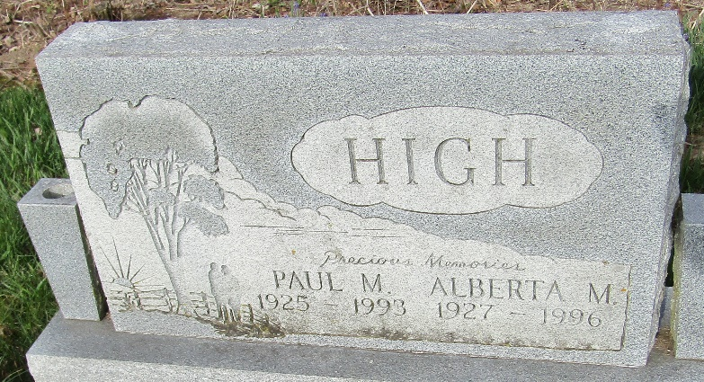

Paul M High
in the Indiana, U.S., Death Certificates, 1899-2017
Name Paul M High
Gender Male
Race White
Marital Status Married
Age 67
Birth Date 14 Aug 1925
Birth Place Fort Wayne, Indiana
Death Date 2 Apr 1993
Death Place Bluffton, Wells, Indiana, USA
Death Registration Date 1993
Father Dayton High
Mother Ethel Sanford
Spouse Alberta M Waggoner
Informant Alberta M. High; wife; Bluffton, Indiana
Burial April 5, 1993; Murray Cemetery; Bluffton, Indiana

