Nora Lell High
April 29, 1906 – February 16, 1909

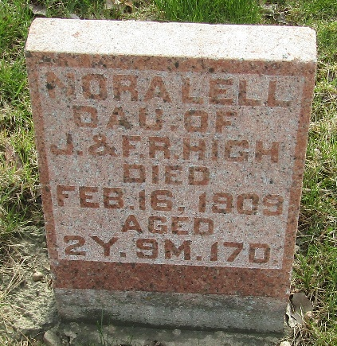

Nora Lell High
in the Indiana, U.S., Death Certificates, 1899-2017
Name Nora Lell High
Gender Female
Race White
Marital Status Single
Age 2
Birth Date 29 Apr 1906
Birth Place Lancaster
Death Date 16 Feb 1909
Death Place Lancaster, Wells, Indiana, USA
Death Registration Date 1909
Father James Ephraim High
Mother Farry Lesh
Informant Joe Bill High; Craigville, Indiana
Burial February 18, 1909; Murray Cemetery

