Mary Jane (Essner) High
May 5, 1865 – September 6, 1892

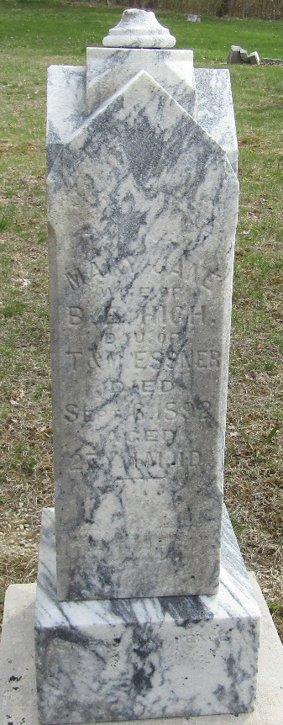

Mary J Essner from tree Jo McCallin Frank
Birth 5 May 1865 Indiana, USA
Residence 1880 Wells, Indiana, USA
Marriage 25 Mar 1891
Death 6 Sep 1892
Father Theobold Jr. Essner (1825-1871)
Mother Ann Margaret Fisher (1833-1906)
Spouse Benjamin High

