Mary (Dare) High
March 1, 1793 – October 18, 1871

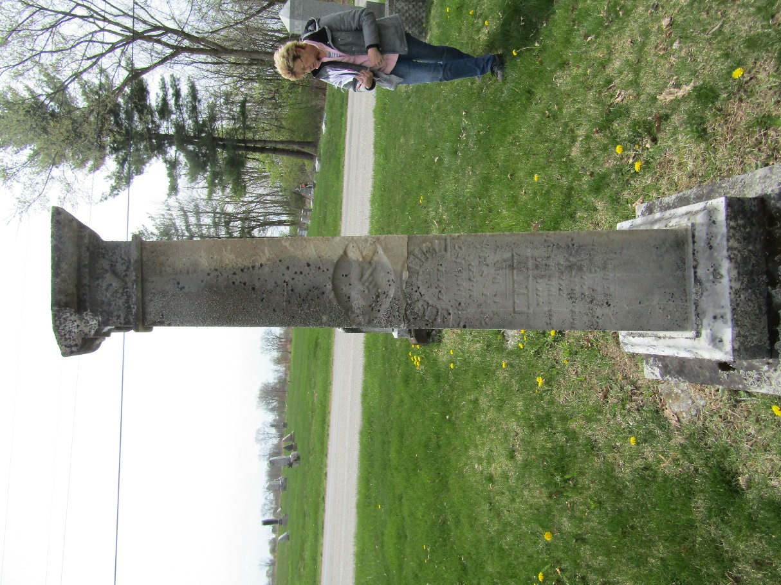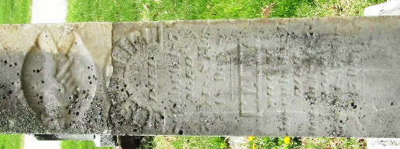

Mary Dare/High from tree Spencer Family Tree
Birth 1 Mar 1793 Cumberland, Cumberland, New Jersey, USA
Marriage 13 Nov 1816 Deerfield, Cumberland, New Jersey, USA
Residence 1870 Bartholomew, Indiana, USA
Death 18 Oct 1871 Wells, Indiana, USA
Father Benjamin 'Benoni' Dare (1770-1843)
Mother Sarah Filer/Dare (1772-1850)
Spouse Joseph High (1794-1874)

