Margaret J. High
1858 – June 5, 1861

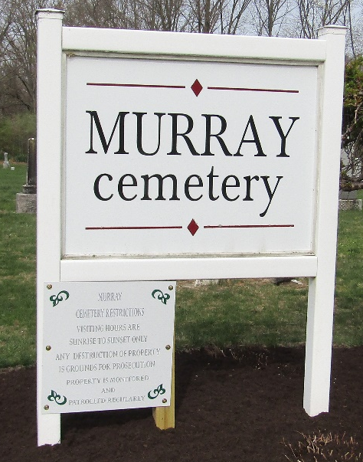

Margaret J High from tree moms tree
Birth 1858 Wells, Indiana, USA
Residence 1860 Wells, Indiana, USA
Death 5 Jun 1861 Wells, Indiana, USA
Father Enoch Joseph High (1827-1875)
Mother Elizabeth Dailey (1828-1872)

